Sale!
NEW! NEW! NEW!
LAPTOP COMPUTERS AVAILABLE FOR SALE AT DISCOUNTED RATES.

Item Listing 1: HP P2000
15% off!
NOW $400
Item Listing 2: ACER
10% off!
NOW $500

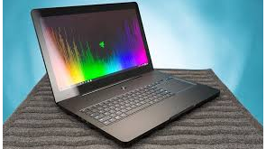

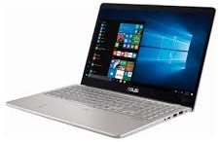

BETTROY COMPUTERS & ACCESSORIES
Street Address
AVENUE 123, FLORIDA
CALL: 555,416,5555
VISIT:www.bettroycomputers.com
Store hours:
08:00 AM – 9:00 PM (M through F)
9:00 AM – 4:00 PM (Weekends and Holidays)

Sale prices good through 11/17/03
Store Hours:
10:00 A.M. – 5:00 P.M. (M thru F)
9:00 A.M. – 6:00 P.M. (Sat. & Sun.)
Daniel Escapa
Fine Art
98765 Main Street
Savannah, GA 98031
Located in Harrington across from Memorial Park

